**Plan Review & Routing Comment Form**

|  |  |
| --- | --- |
| **Project Information** | |
| Project: | Auburn Community Commons - Development Plan |
| Revision: | Preliminary |
| Type: | Development Plan |
| Logos ID: | PROJ-PUBLIC - 2020-00000002 |
| Due Date: | **Jan 15, 2020** |

|  |
| --- |
| **Comments** *(add more numbers and pages, if necessary)* |

**Auburn Electric/Auburn Essential Services (Rob Higgins – 260 925-8232) - Approve**

**Building (Mat Snyder – 260 925-6449) – Approve with Comments**

1. Strongly suggest soil borings on the side since there was a home demolished at this site. The soil borings should provide some indication of what was used for fill dirt, if there was compaction at the time of fill, and if the soils will support the proposed structure.
2. Suggest that the “mechanical corridor” be made bigger as 2-feet 8-inches is not a lot of room for maintenance. The minimum required is 2-feet 6-inches, but 4-feet is preferred.

**DeKalb Co Soil & Water (Allen Haynes – 260 925-5620) – Other**: Based on the information provided for the project listed above, permitting for compliance with 327-IAC-15-5 would not be required. Per the rule, while permitting would not be applicable, the intent of the Rule is to be observed during development.

**Engineering (Daryl McConnell – 260 925-6264) – Approve with Comments**

1. Currently it is uncertain as to where the original sanitary sewer tap is located that once serviced this property. It is advised that a new sanitary tap be installed to service this new facility.
2. A storm sewer tap will also be necessary to service this new facility with direct connection to the roof drain system as to not shed water run-off onto adjacent properties to the north and west. There are currently no dedicated storm sewers in this area, only combination sewers. However, there are intentions to install a new dedicated storm sewer down 6th Street within the next 2 years. A new storm sewer tap could be run parallel with a new sanitary sewer tap, possibly to the north towards 6th Street, through the north-adjoining property of “Snyder”. Once into the right of way of 6th Street, the storm tap could be connected to the sanitary tap and allowed to temporarily drain to the combination sewer. At such time when a new dedicated storm sewer is installed, the storm sewer would be disconnected from the sanitary tap and tied into the new storm sewer.

**Fire (Ryan Shambaugh – 260 925-8240) – Approve**

**Planning (Amy Schweitzer – 260 925-6449) – Other: No significant compliance issues**

Zoning / Compliance Related

1. This project falls under the definition of “Park, Public” and is permitted in this district.
2. Property is zoned Downtown Commercial and is within the Wellhead Protection Overlay.
3. The County owns the property. How will this be handled?
4. Development Plan approval is required via the Plan Commission. When this project is routed for Plan Commission, we will also route it to DARC (Downtown Auburn Review Committee).
5. Local Building Permit and Indiana Construction Design Release is required. Building Construction Plans will need routed and reviewed in addition to the Development Plan. (These routings may be concurrent.)
6. Provide Structure Height at the highest point.
7. Utility and drainage plans will be required.
8. Will there be a dumpster?
9. We will need more details on any exterior lighting (light specs/details, light locations, photometric plan); signs; and solar components.

Opinion/Design Preferences

1. Security concerns with opened all day, every day
2. We’d strongly encourage incorporating some sort of storage area within the maintenance space. There always seems to be a need for secured storage areas in downtown.
3. Please consider alternatives to the roof line to allow for natural light and air:

* 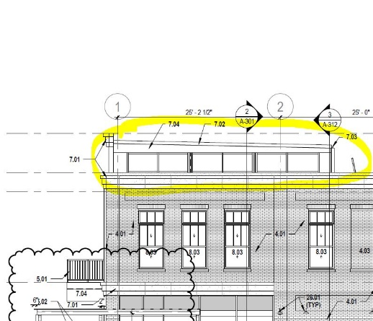Leaving the roof off the open area and designing it to be an open air plaza. It could still have the columns and trusses.
* Similar to TQS, one portion of the roof being taller than the others with some open air vents (see image)

**Street (Troy Ackerman – 260 925-6455) – Approve with Comments**

1. INDOT permits required for work performed within ROW.

**Water (Randy Harvey – 260 925-5711) – Approve with Comments**

1. GIS records indicate this water service has been abandoned. Regardless, a new water service is highly recommended as the material type has likely reached or near the end of its useful life or is no longer composed of an acceptable material for potable water.

**Water Pollution Control (Todd Sattison – 260 925-1714) – Approve with Comments**

1. In discussion with the Engineering Dept. A new tap for both Sanitary and Storm may be preferred toward 6th St.